3.2.1 Institution has created an ecosystem for innovations, Indian Knowledge System (IKS), including awareness about IPR, establishment of IPR cell, Incubation centre and other initiatives for the creation and transferof knowledge/technology and the outcomes of the same are evident

###### ESTABLISHMENT OF VARIOUS CELLS TO PROMOTE INNOVATION AND ENTREPRENEURSHIP

**IP CELL**

Sir MVIT-KSCST IP is constituted in collaboration with The Karnataka State Council for Science and Technology (KSCST), Head by: Mr. H. Hemanth Kumar, Executive Secretary. KSCST along with Patent Information Centre (PIC), tirelessly willing to create awareness, capacity building, basic and advance training programmes on Intellectual Property Rights (IPRs). Further PIC KSCST is establishing IP cells across Karnataka in Science/Engineering Institutions / Universities and Cell for IPR Promotion and Management (CIPAM), A professional body under the aegis of Department for Promotion of Industry and Internal Trade (DPIIT), Govt of India, which ensures focused action an issue related to IPRs and addresses the identified objectives of the policy.

SIRMVIT-KSCST IP CELL will provide support & guidance to the students, research scholar, faculty members and industry personals in & around our Institution in protecting inventions and creations.

The Objectives of the IP Cell are:

* To create an awareness about IPR among the faculty and students.
* To conduct workshops and seminars on IPR.
* To educate faculty about the procedure of patent filing.
* To enable patent searches for industry and RD institutions.
* To guide inventors in respect of patenting their inventions.

The Outcomes of the IP Cell are:

The outcome of the IP Cell will be providing support & guidance to the students, research scholar, faculty members in protecting inventions and creations. The Cell will Work as bridge between Patent Information Centre& research center’s of the College & Guide students, research scholars and faculty members on the importance of IPR, especially on patents. The IP Cell will arrange periodic meetings of groups of students, research scholars and faculty members with officers of Patent Information center.

Sir MVIT–KSCST Intellectual Property Cell was inaugurated at Sir MVIT

Shri. K. Syama Raju, Secretary, Sri Krishnadevaraya Education Trust inaugurated the Intellectual Property (IP) Cell at Sir.M.Visvesvaraya Institute of Technology, Bengaluru here on Friday 16th October 2020. The other dignitaries present were Shri G. Prabhakar Raju, Academic Chairman, SirMVIT, Dr V R Manjunath, Principal, SirMVIT, Dr. H L Suresh, HOD-Electrical, Sir MVIT, Mr. C. Babu Raju, Asst Manager, Sir MVIT and Dr.Mahesh.K, Coordinator, SirMVIT-KSCST IP Cell. This was established with the technical support of KSCST, Bengaluru. Mr. Vivek Anand Sagar IP Attorney and Consultant, KSCST and Mr. Nagarjun, Project Associate at KSCST.

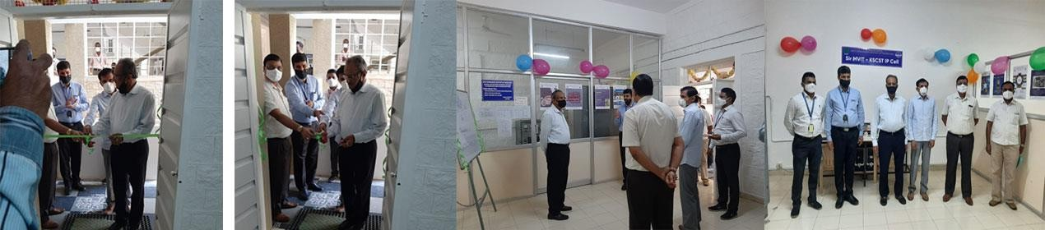

Following are the Details of IPR related activities

|  |  |  |
| --- | --- | --- |
| **S.**  **No** | **Title of FDP/ Program** | **Date** |
| 1 | Certificate of appreciation for GOI for organizing IPR awareness program | March 18th 2023 |
| 2 | World Intellectual property day celebration | 26/04/2023 |

2 | P a g e

#### ABOUT NATIONAL INNOVATION AND START-UP POLICY 2019

The National Innovation and Start-up Policy 2019 for students and faculty of Higher Education Institutions (HEIs) will enable the institutes to actively engage students, faculties and staff in innovation and entrepreneurship related activities. This framework will ~~also~~ facilitate Ministry of Education in bringing uniformity across HEIs in terms of Intellectual Property ownership management, Technology licensing and policy, to enable creation of a robust innovation and Start up ecosystem across all HEIs.

###### OBJECTIVES

India aspires to become 5 trillion-dollar economy by 2024. To reach the mark, it needs to evolve systems and mechanisms to convert the present demographic dividend into high quality technical human resource, capable of doing cutting edge research and innovation towards deep-tech entrepreneurship. The 'National Student and Faculty Start-up policy 2019' is a guiding framework to envision an educational system oriented towards start-ups and business opportunities for student and faculties. The guidelines provide ways to Indian HEIs for developing entrepreneurial agenda, managing Intellectual Property Rights (IPR) ownership, technology licensing and equity sharing in Start-ups or enterprises established by faculty and students. In India, innovation is still not the epicenter of educational systems. In order to achieve the above goals and ambitions and to ensure that “Innovation and Start- up‟ culture is the fulcrum of our higher education system, a policy framework is the need of the hour. These guidelines will enable institutions to actively support their faculty, staff and students to participate in innovation and entrepreneurship (I&E) related activities, thus encouraging students and faculty to consider start-ups and entrepreneurship as a potential career option.

4 | P a g e

###### VISION

To motivate, promote, guide and handhold the students and staff who wish to envisage and embark upon entrepreneurial journeys

###### MISSION

To motivate the aspiring students/staffs to envision and empower entrepreneurial thinking and business acumen via awareness programs, interactive sessions, idea to PoC competitions, DIY hackathons, business meets, GDs, networking events, etc.

###### OBJECTIVES

* To inculcate the passion and spirit among the students/staff to pursue entrepreneurship.
* To spread the knowledge about entrepreneurial opportunities through expert talks and events etc.
* To facilitate the students/staff towards pitching their ideas and provide them suitable opportunities and platforms for developing them as business models.
* To support successful students/staff to develop their own enterprises.

###### SHORT TERM OBJECTIVES (0-12 MONTHS)

* Strengthen the activities of Institute Industry Interaction Cell
* Organize FDP, seminars, workshops and talks for students/Faculty from subject matter experts to promote the entrepreneurial ecosystem.
* To conduct events like idea to PoC competitions, DIY hackathons, business meets, GDs, networking events, etc. to scout for creative talent, novel ideas and passionate groups
* To support these innovative teams achieve their entrepreneurial goals and ambitions.

###### LONG TERM OBJECTIVES (0-36 MONTHS)

* To associate with DST, DBT, MSME, and other organizations ~~academic~~ to promote Entrepreneurial activities
* To Apply for schemes under National Innovation Foundation (NIF) of India
* To set up an Entrepreneurship Development cell through funding from AICTE
  + To explore funding opportunities from various external agencies.

5 | P a g e

* + To inculcate and improve research and consultancy cultures amongst students and faculty, thereby achieve generating quality IPs.
  + To promote successful business models and opportunities globally.

###### THE POLICY

1. STRATEGIES AND GOVERNANCE IN IMPLEMENTING POLICY

Strategies and governance:

1. Minimum 1% fund of the total annual budget of the institution to be allocated for supporting innovation and startup related activities.
2. This will be supplemented with funding from various bodies like DST, DBT, MHRD, AICTE, TDB, TIFAC, DSIR, CSIR, BIRAC, NSTEDB and NRDC.
3. The Institute Innovation Council shall, with the support of the institute regularly conduct workshops, hackathons, and webinars.
4. The Action plan and assessment shall be disseminated to all stakeholders.

###### ENABLING INSTITUTIONAL INFRASTRUCTURE:

1. The Institute will strengthen its IIC, IPR cell, Entrepreneurship Development cell towards developing Innovation and Entrepreneurship activities.

Nurturing Innovations and Start ups

1. The Institute shall offer its facilities to faculty, students and potential innovators.
2. Student / Faculty entrepreneurs may be permitted to use the infrastructure and facilities of the Institute based on formal consents.

Product Ownership Rights for Technologies Developed at Institute

* 1. Joint ownership or acknowledging the Institute may be assured when a patent/publication is developed using the facilities of the Institution.
  2. The Institution will provide assistance and guidance for innovative research and IP management via the IP cell.

Organizational capacity, human resources and incentives

1. Faculty members will be trained and given exposure to Innovation and Entrepreneurship.
2. Inter departmental projects and linkages will be strengthened to gain better

6 | P a g e

knowledge.

1. Guest lectures by experts and alumni in the domains will be organized on a time to time basis.
2. Faculty members will be encouraged to do add-on courses/certification courses on Entrepreneurship and IP management.
3. Reward mechanisms will be formulated to acknowledge the faculty who involve in innovation, entrepreneurship management, venture development management and IPR management.

Setting innovation pipeline

1. The IIC shall ensure that maximum students are exposed to innovation and pre incubation activities
2. The IIC shall handhold the talented groups during the process of ideation to innovation to business models
3. The IIC shall conduct various activities related to innovation, startup and entrepreneurship development.
4. The IIC shall coordinate Networking events to create a platform for the budding entrepreneurs to meet investors and pitch their innovative business ideas/concepts.

Collaboration co-creation business relationships and knowledge exchange

* 1. Collaboration will be made with social enterprises and professional bodies, to strengthen the Innovation and Entrepreneurship ecosystem.
  2. Internships and collaborative projects may be undertaken in Industries through MoUs.
  3. The IIC will welcome Feedback and suggestions from Stakeholders to strengthen the innovation ecosystem in the campus.

###### IMPACT ASSESSMENT

1. Impact assessment of institute’s entrepreneurial initiatives such as pre- incubation, incubation, entrepreneurship education will be performed regularly using well defined evaluation parameters.

7 | P a g e

### NISP PLANNING & MONITORING COMMITTEE

|  |  |  |
| --- | --- | --- |
| **INTERNAL MEMBERS** | | |
| Sl No | Name | Designation |
| 1 | Dr. S G Rakesh (Principal) | Principal (Chairperson) |
| 2 | Dr Priya Narayan | Dept of BT Sir MVIT (Coordinator) |
| 3 | Dr Priyanka Sharma | Dept of MBA (Member) |
| 4 | Dr Mahesh K (EEE) | Dept of EEE (Member) |
| 5 | [Dr. R. Sivapriyan](https://www.sirmvit.edu/sivapriyan-r/) | Dept of EEE (Member) |
| 6 | Prof Muthuramalingam | Dept of MCA (Member) |
| 7 | Mr Abhishek Thakur | Student Coordinator |
| **EXTERNAL MEMBERS** | | |
| Sl No | Name | Designation |
| 1 | Dr R Nagaraja | Managing Director, Power Research & Development Consultants Private Limited |
| 2 | Mrs Revathy Ashok | Startup Evangelist, Angel Investor, Co-Founder Strategy Garage, Former MD Tishman  Speyer |
| 3 | Dr Susheela Venkataraman | Governing Council Member and Joint Secretary at IIT Alumni Centre, Bengaluru |
| 4 | Mr Shrinivas BV | Director & CEO at Aspartika Biotech Pvt Ltd |
| 5 | Mr. Nagachethan S M | Head, Housing Business at Navi FinServ Private Limited | Bharat Inclusion Initiative Fellow |

8 | P a g e

#### INSTITUTE INNOVATION COUNCIL MEMBERS

|  |  |  |  |
| --- | --- | --- | --- |
| **Sl.No.** | **Name** | **Department / Designation** | **Responsibility** |
| 1 | Prof. Rakesh S.G. | Principal | Chairman |
| 2 | Dr. Vanipriya C.H. | HoD-MCA | President |
| 3 | Dr. Soumya Pail | CSE | Vice-President |
| 4 | Dr. Sasmita Mohapatra | ECE | Convenor |
| 5 | Dr. Priyanka Sharma | HoD-MBA | Startup Activity Coordinator |
| 6 | Dr. E. Kavitha | HoD-ETE | ARIIA Coordinator |
| 7 | Dr. Priya Narayan | BT | Innovation Activity Coordinator |
| 8 | Dr. Shantha V. | ME | Internship Coordinator |
| 9 | Dr. Mahesh K. | EEE | IPR Activity Coordinator |
| 10 | Dr. Jagadeesh Kumar | BT | Social Media Coordinator |
| 11 | Dr. H.G. Nagendra | HoD-BT | Member |
| 12 | Dr. Supriya V.G. | ECE | Member |
| 13 | Dr. Hariharan N. | HoD-Phy | Member |
| 14 | Mr. K.V.R. Prasad | CV | Member |
| 15 | Dr. Balakumar | ME | Member |
| 16 | Ms. R. Latha | MCA | Member |
| 17 | Dr. Prashanth G.K. | Chemistry | Member |
| 18 | Mr. Phaninder Ravi P. | ECE | Member |

9 | P a g e

|  |  |  |  |
| --- | --- | --- | --- |
| 19 | Dr. Rashmi K.V. | BT | Member |
| 20 | Ms. Sreelakshmi T. | ETE | Member |
| 21 | Ms. Deepti M. | MBA | Member |
| 22 | Ms. Asharani | ME | Member |
| 23 | Ms. Chandrakala | MCA | Member |
| 24 | Mr. K. Radhakrishna | ECE | Member |
| 25 | Ms. Savithri R. | CSE | Member |
| 26 | Ms. Netravathi S. | CSE | Member |

#### MEMBERS OF E CELL

###### CONSTITUTION OF ENTREPRENEURSHIP DEVELOPMENT CELL AND NATIONAL INNOVATION

**AND START UP POLICY**

|  |  |  |
| --- | --- | --- |
| **INTERNAL MEMBERS** | | |
| Sl No | Name | Designation |
| 1 | Dr. S G Rakesh (Principal) | Principal (Chairperson) |
| 2 | Dr Priya Narayan | Dept of BT Sir MVIT (Coordinator) |
| 3 | Dr Priyanka Sharma | Dept of MBA (Member) |
| 4 | Dr Mahesh K (EEE) | Dept of EEE (Member) |
| 5 | [Dr. R. Sivapriyan](https://www.sirmvit.edu/sivapriyan-r/) | Dept of EEE (Member) |
| 6 | Prof Muthuramalingam | Dept of MCA (Member) |
| 7 | Mr Abhishek Thakur | Student Coordinator |
| **EXTERNAL MEMBERS** | | |
| Sl No | Name | Designation |
| 1 | Dr R Nagaraja | Managing Director, Power Research & Development Consultants Private Limited |
| 2 | Mrs Revathy Ashok | Startup Evangelist, Angel Investor, Co-Founder Strategy Garage, Former MD Tishman  Speyer |
| 3 | Dr Susheela Venkataraman | Governing Council Member and Joint Secretary at IIT Alumni Centre, Bengaluru |
| 4 | Mr Shrinivas BV | Director & CEO at Aspartika Biotech Pvt Ltd |
| 5 | Mr. Nagachethan S M | Head, Housing Business at Navi FinServ Private Limited | Bharat Inclusion Initiative Fellow |

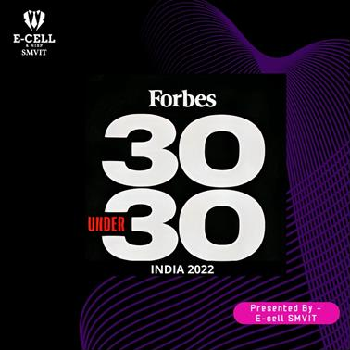

Our social network: Backed by the Media Publicity team and our student Leader Abhishek Thakur, our Instagram page of E-Cell has come out with a series of 30 posts of Forbes 30 under 30 India. The Insta page will also post different case studies about start-up unicorns and brands, strategies they follow, study of the entrepreneurial mindset, the college startups and interview sessions.

**Abhishek Thakur from II Semester CSE has been selected as Campus Ambassador through the IIT Bombay e cell.**

**Congratulations Abhishek!!**

##### The following are the events conducted during the year 2014 to 2023 under E-Cell

|  |  |  |
| --- | --- | --- |
| **Sno** | **Date** | **Activities** |
| **2014-2015** | | |
|  |  | **2022-2023** |
| 9 | 06.07.2022 | Started the Forbes 30 Under 30 India Series on Instagram with the aim of students recognizing Indian Entrepreneurs |
| 10 | 17.07.2022 | Abhishek Thakur(Overall Coordinator) selected as Campus Ambassador from E-Cell IIT Bombay |
| 11 | 04.08.2022 | E-Cell participated in National Entrepreneurship Challenge 2022-23 at E-Cell, IIT Bombay |
| 12 | 11th Aug –  1stOct 2022 | Recruitment Drive for E-Cell Core Team Members |
| 13 | 30.08.2022 | Angel Investments/VC funding opportunities for early entrepreneurs by Dr Lakshm H, Asst Prof Dept of MBA NMIT Bangalore |
| 14 | 17.09.2022 | 9 teams from E-Cell Members participated in EUREKA 2022 |
| 15 | 10.11.2022 | Keerti’s Team got selected for Zonals in Eureka 2022 |
| 16 | 28.11.2022 | E-Cell IIT Bombay Coordinators Visit to Sir MVIT Campus (Ayush Jalan, Lucky) |
| 17 | 11.12.2022 | Induction Programme for 1st year on E-Cell and NISP By the E-Cell Core Team &  addressed nearly 400 students |

|  |  |  |
| --- | --- | --- |
| 18 | 12.12.2022 | Workshop on LinkedIn for Engineering students By Dr. Jagadeesh Kumar D, Asso Prof Dept of BT |
| 19 | 13.01.2023 | E-Cell Sir MVIT got selected as NEC Finalists 2022-23 conducted by E-Cell, IIT Bombay  (Out of 975 Teams) |
| 20 | 26th – 29th January 2023 | Attended E-SUMMIT 2023 conducted by IIT Bombay and secured 23rd Rank across India |
| 21 | 04.02.2023 | Exploring Metaverse with E-Cell SMVIT Event by Pushpak Kypuram, Co-Founder of NextMeet, |
| 22 | 26.02.2023 | IDO Launch and Hands-on Experience of Metaverse By NextMeet |
| 23 | 18.03.2023 | In Campus Ambassador Program lead by E-Cell IIT Bombay 2022-23, Abhishek secured 34th Rank with Platinum Badge |

**E-SUMMIT’23 IIT BOMBAY**

Students Represented E-Cell SMVIT in IITB:

1. Abhishek Thakur (1MV21CS002)
2. Atharv Agrawal (1MV21CS015)
3. Mehul Chandak (1MV21CS054)
4. Purushuttum Kumar (1MV21EC074)
5. Nitin Singh (1MV21CS066)

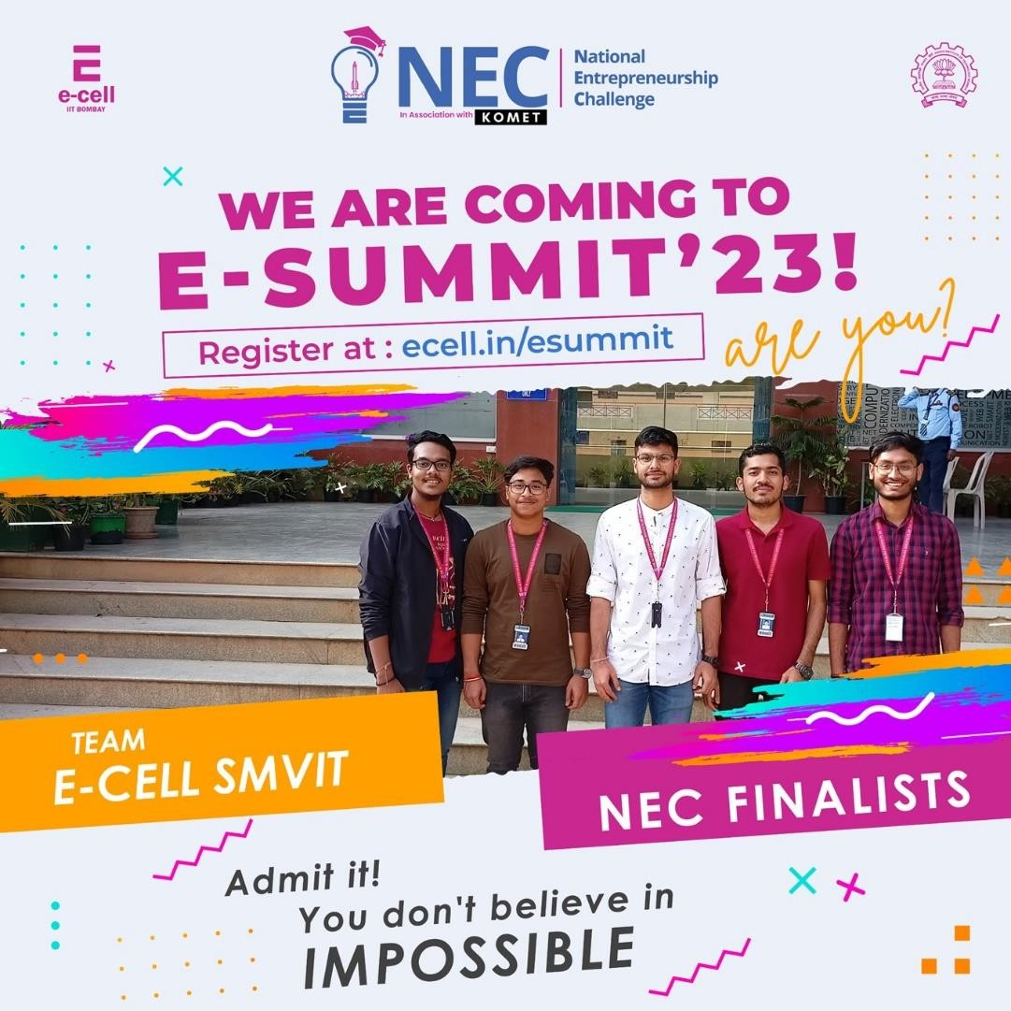

Reported at IIT Bombay on 26th Jan, 2023.

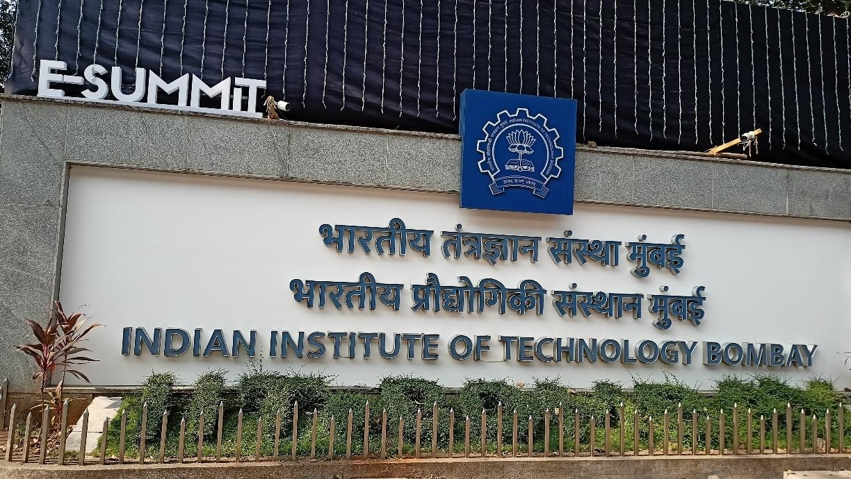

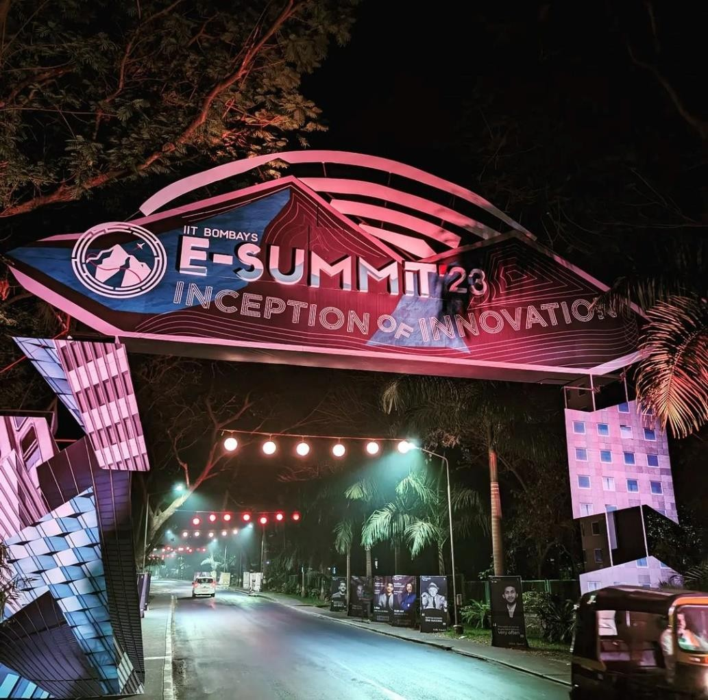

Accomodation Facility

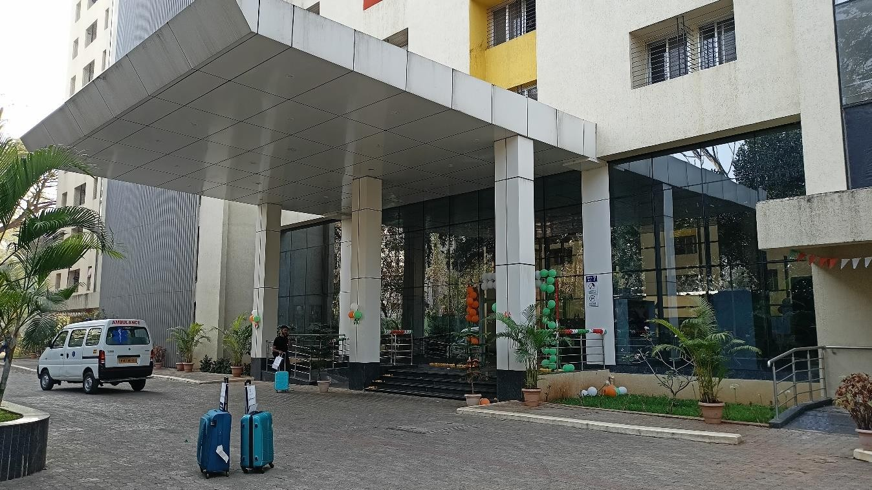

Events

Day 1(Orientation)

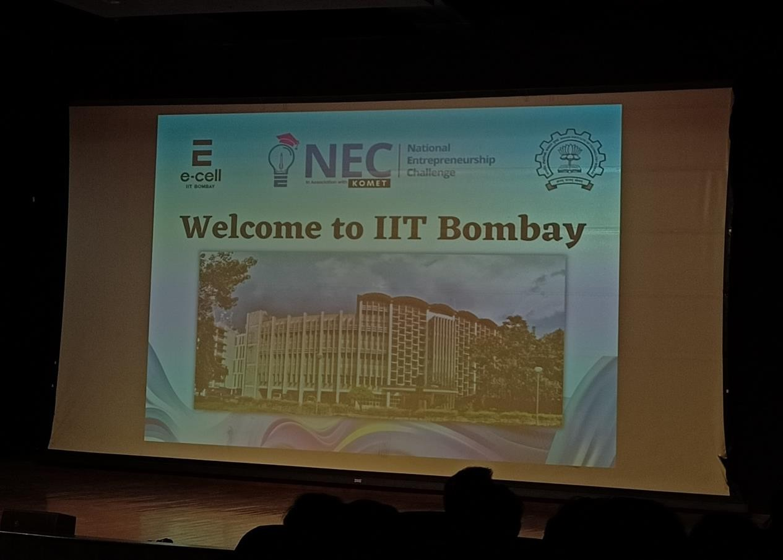

* The E-Cell IITB NEC Coordinators briefed us about the whole Events which is going to happen in the E-SUMMIT.
* Workshop Session of Wadhwani Foundations, in which they explained us various schemes,requirements and problems faced by any new growing E-Cell.
* About the E-Cell building, like how they can help in scaling and setting up our E- Cell.
* INDIGG(India’s Largest Web3 Gaming Community) Workshop, they told us about the various games and tournaments related to Web3 which can help the gaming community grow quickly and strongly.
* Small activity related to team building and documentation(Questionaire).
* National Entrepreneurship Challenge(NEC) Rounds
  1. Pre-Semi Final Round (Qualified) : Quiz(JEE Like Pattern) + Case Study.
  2. Semi-Final Round (Eliminated) : Problem Analysis + Situation study related to Event.
* Networking with Other E-Cell and their Team Members.

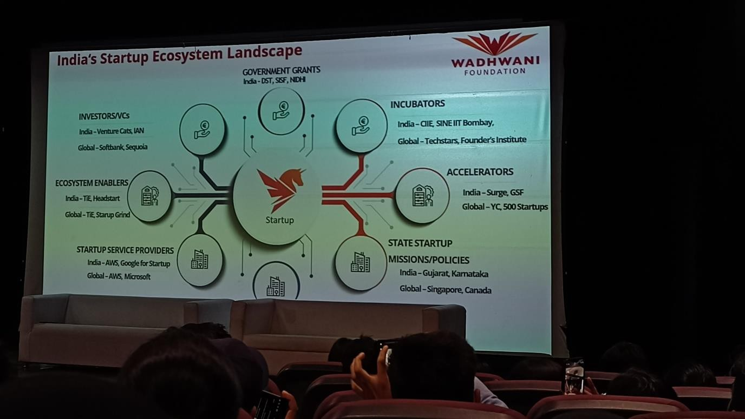

Day 2 Speaker Sessions

KeyNote Sessions

* Aman Dhattarwal – Founder of ApniKaksha
* Mr. Kishore Jayaraman – President of Rolls Royce India
* Lalit Keshri – Founder of Groww
* Ravi Pasupuleti – Managing Director of JP Morgan & Chase Co.
* Ashneer Grover – Founder of Bharatpay and Shark tank India Judge.

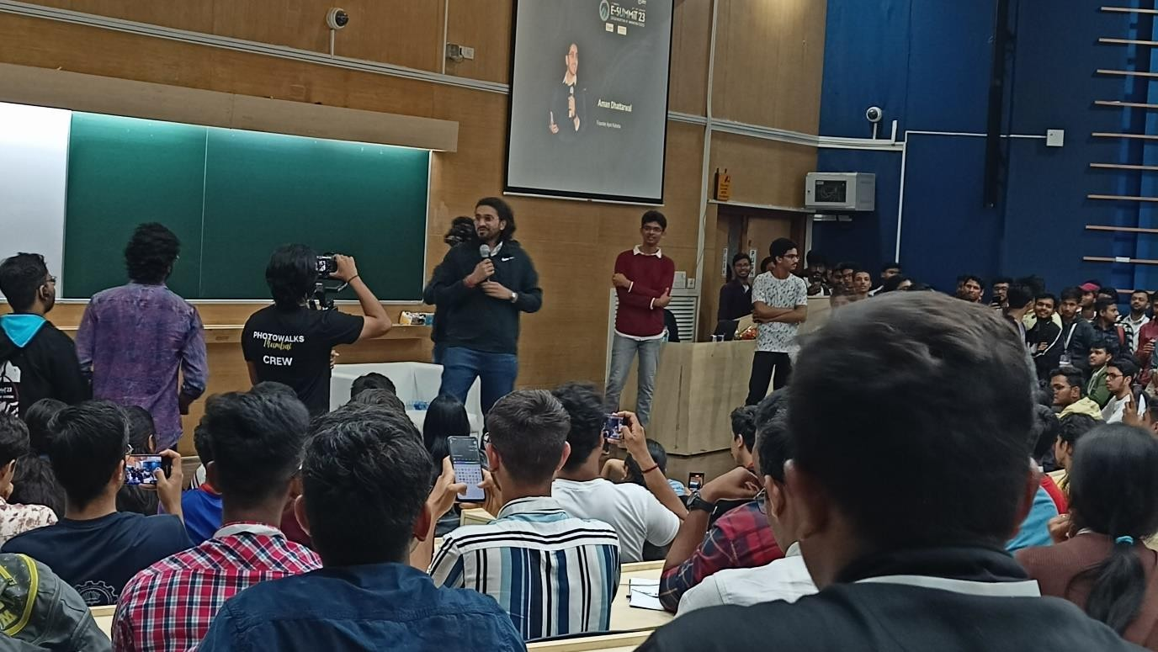

Events

* Ten Minute Million
* Aakash Gupta – StandUp Comedian
* Networking

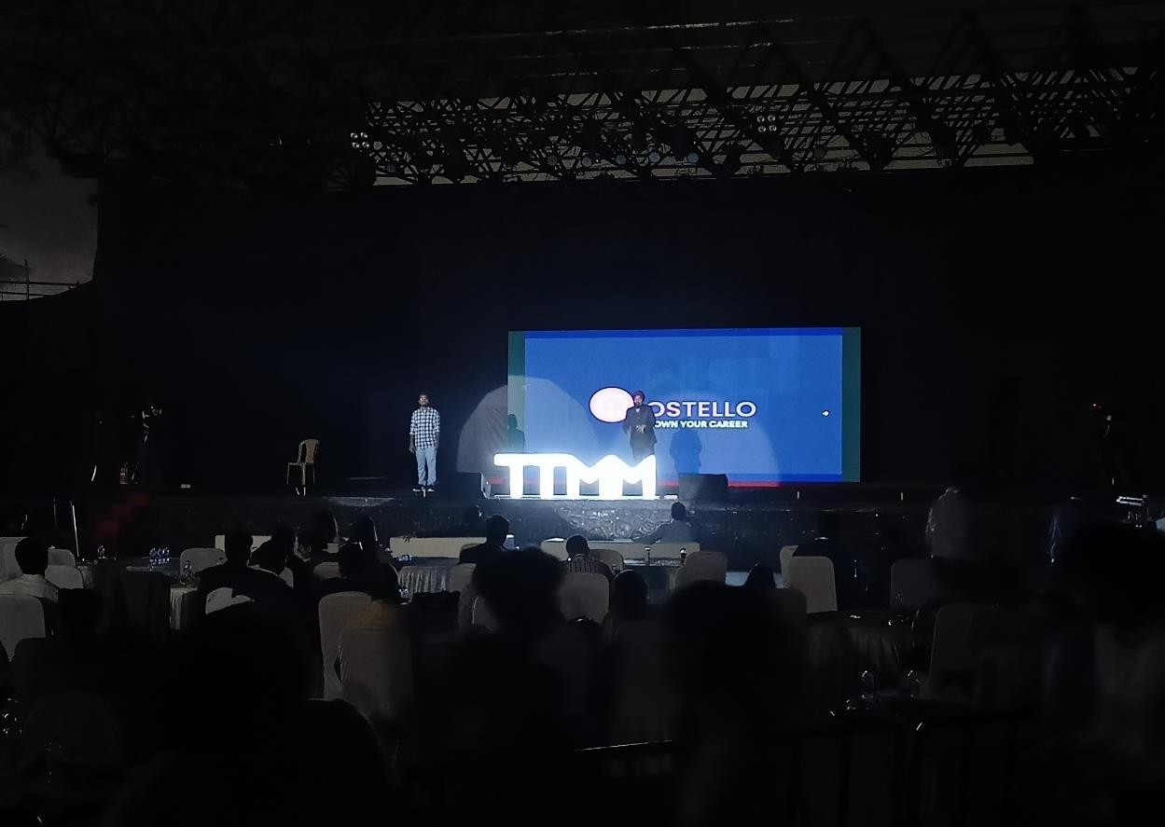

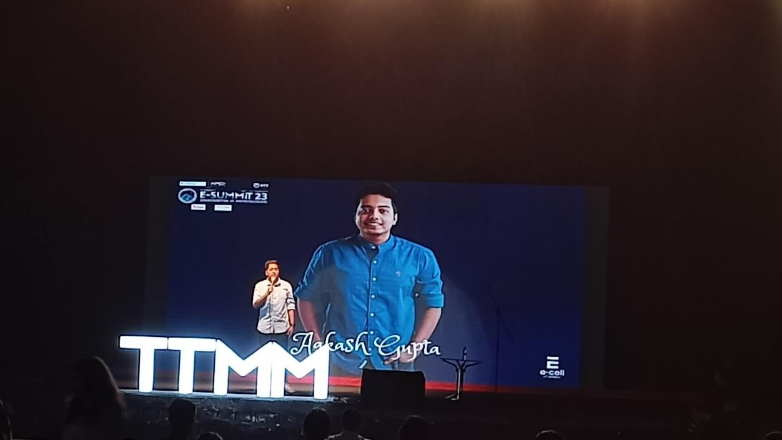

KeyNote Sessions

Day 3 Speaker Sessions

* Barkha Dutt – Indian Journalist, Author & Founder of MojoStory
* Round 2 Hell – Youtube Content Creator
* Shri Gauranga Das – ISCKON GBC & Director GEV, Spiritual Speaker
* Ashish Arora – Founder of Physics Galaxy, HOD of Allen Kota
* Vedantu Founders – Pulkit Jain, Anand Prakash & Vamshi Krishna
* Kaivalya Vohra – Founder of Zepto

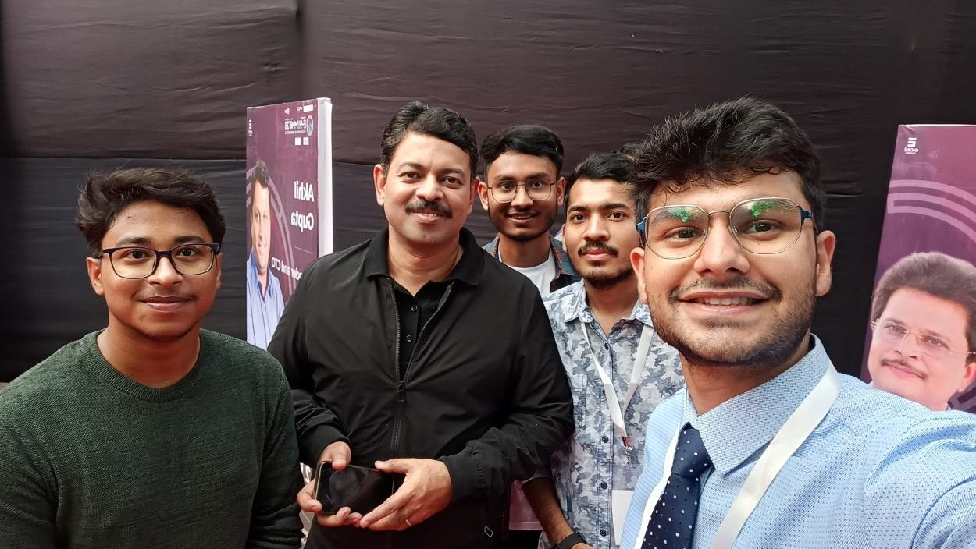

Events

* Gaurav Chaudhary – Youtuber aka Technical Guruji, Listed in Forbes 30 Under 30 (2020)
* Shruti Haasan – Artist & Entrepreneur
* Priyanka Khemani – Founder of Khemani & Associates.
* Ten Minute Million
* Biswa Kalyan Rath – StandUp Comedian
* Networking

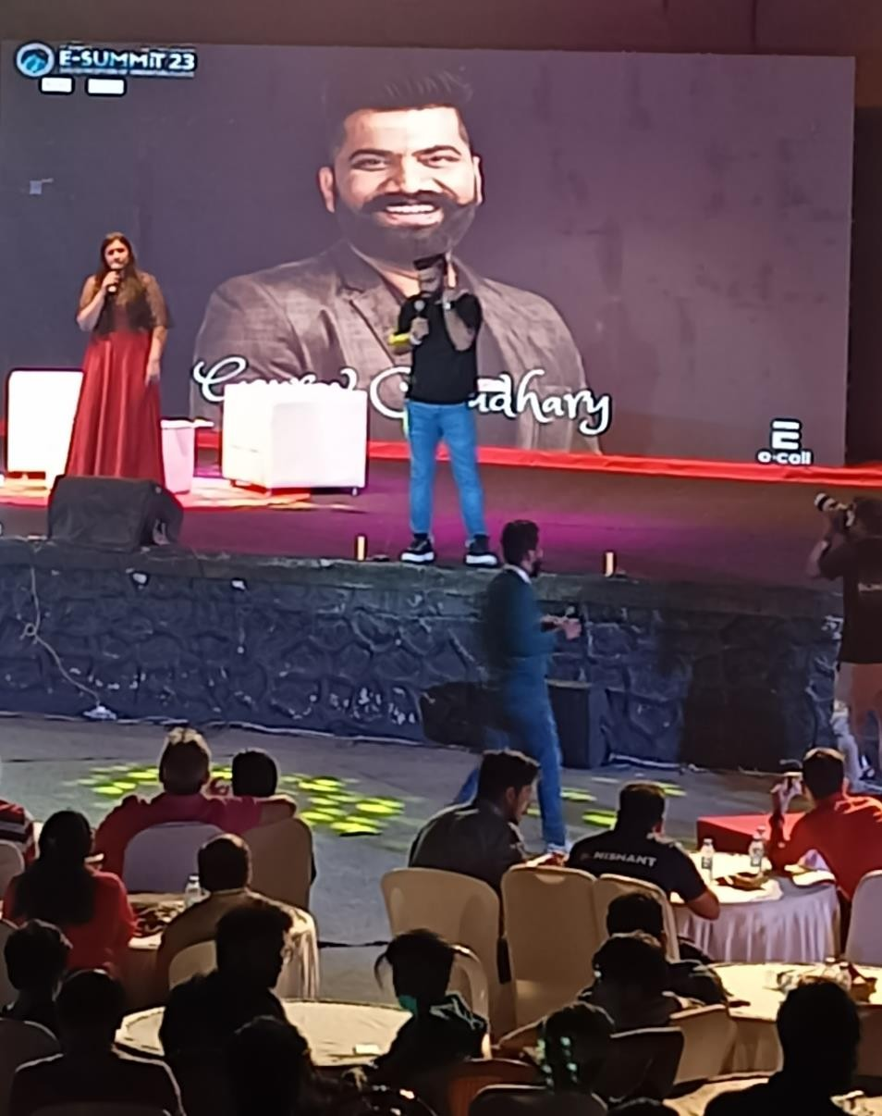

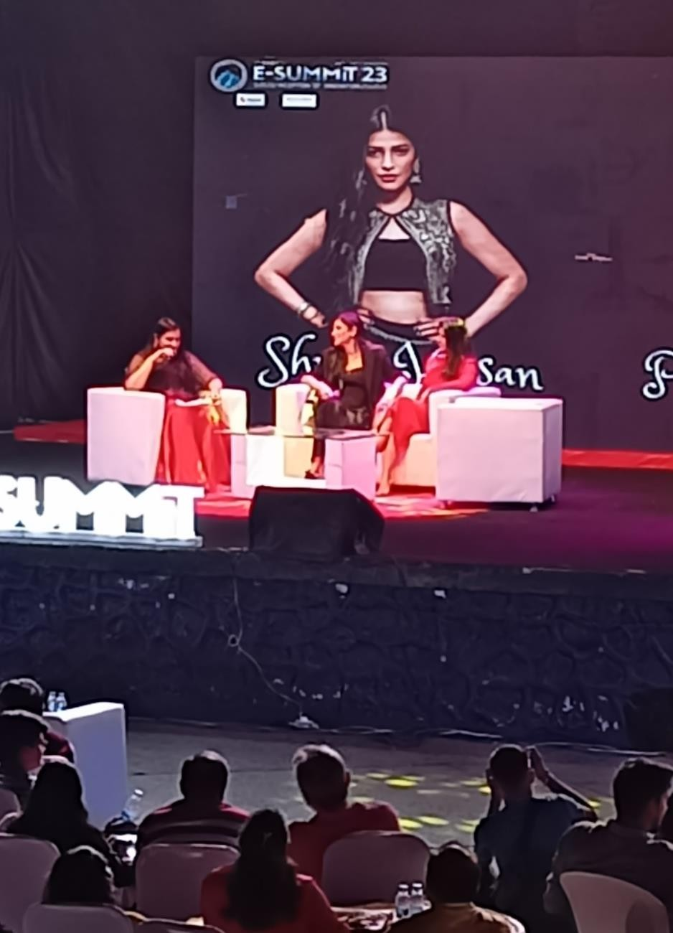

Experience gathered & Implementations

* Strong Dedicated Team
* Proper Workspace and work timings
* Networking with other E-Cell People
* Support, Funding from College & Outside Companies
* Conducting Event on Large Scale
* StartUp Alumni List from all Departments
* Crowd Handling – What all things to be avoided during events
* Properly Documented information and plannings
* A Community of all E-Cells in Bangalore
* Service based StartUp in College Campus

Future Planning

* Session related to NEC about E-Cell sharing our experience with our peeps.
* TechFest in collaboration with other technical clubs of our College.
* E-Summit of our own college.
* Enhancing Startup ecosystem in our campus.

**FACULTY MENTOR**

Dr. Jagadeesha Kumar D

Associate Professor, Dept. of Biotechnology Sir MVIT, Bangalore

**EXE-COM**

1 Gagana R - 1MV20EC048 - Secretary

1. Arjun Kanthimath -1MV21ET004 - Coordinator
2. Abin Mathew -1MV21ET001 - Coordinator

It is rightly said that “everything begins with an idea. “Henry Ford says that “the air is full of ideas. They are knocking you in the head all the time. You only have to know what you want, then forget it, and go about your business. Suddenly, the idea will come through. It was there all the time.” Ideas are continuously generated in our minds. Initially most of the ideas seem to be foolish and absurd. In fact, according to Albert Einstein, **“If at first the idea is not absurd, then there is no hope for it.”** Roosevelt says that “great minds discuss ideas, average minds discuss events and small mind discuss people.” In this context, George Bernard Shaw has rightly said that “If you have an apple and I have an apple and we exchange these apples, then you and I will still each have one apple. But if you have an idea and I have an idea and we exchange these ideas, then each of us will have two ideas.”

**NEED OF INNOVATION CLUB**

Now, in view of the present initiatives of Government of India like Make in India, Start-up India, Digital India etc., the role of education sector becomes more important to harness the creative potential of the large young population of the country. Moreover, the inclusion of large number of manufacturing industry and IT industry have generated a huge demand for quality and skilled manpower in the country.

As a matter of fact, in the present age of competitions and technologically fast growing society, our youth particularly the students’ needs to be futuristic and innovative. For that purpose, besides technological empowerment of the students, they need to be encouraged to be entrepreneurs and innovators. Through this coloumn effort will be made to describe ways and means to foster the culture of innovation in Sir MVIT college. Innovation club in college could be the best platform to discuss ideas and thus promote the culture of innovation in schools and colleges.

**OBJECTIVES OF THE CLUB**

For promoting the culture of innovation, **INNOVATION CLUB- SIR MVIT** will provide conducive environment for exchanging the ideas, among the students and faculty. Discussing ideas itself indicates the greatness of the minds i.e. The students and faculty. Thus, the students coming up with any kind of new and innovative idea or innovation should be encouraged and be discussed regularly in the Innovation Club-of Sir MVIT Platform.

Besides generating awareness about creativity and innovations among the students and faculty the basic objectives of the Sir MVIT Innovation Clubs could be as follows:

* + To identify and promote the grass-root level innovations by the faculty as well as the students;
  + To provide a platform to share new and innovative ideas,
  + To support and nurture the innovators both intellectually and financially
  + To create a network of innovators and thus creating a culture of innovation in the schools, colleges.

**WHO CAN BE THE MEMBER OF INNOVATION CLUB?**

To begin with Innovation clubs may comprise of imaginative students, faculty and other interested staff members of the Colleges. Later on other students and faculty may also be involved in the activities of Innovation Clubs.

1 | P a g e

**ACTIVITIES OF THE CLUB:**

In order to meet the objectives of the Innovation Club, a verity of activities can be organized on regular basis.

* The innovation club may organize periodic meetings of the club members to generate new ideas and identify innovations by students, faculty, and other staff of the college.
* In addition to it, other students, faculty and staff members may be invited to share their innovative ideas and skills and showcase their innovative products and processes in the form of seminars and conferences.
* The club may also organize awareness campaign and various types of competitions like quiz, debates, posters, etc. on creativity and innovations within college. In fact, it can prove to be a very good platform to the students, faculty and staff to be engaged in the innovative activities and programmes related to institutes.
* In order to publicize the news and views on innovation staking place within the college and as well as outside them, it may be a good idea to publish such information in the form a magazine or newsletter on innovation on a periodic basis. Such periodicals may be brought out in the printed form or even in the electronic form. In will not only encourage students to document their innovations and innovative ideas, but it will be a good means of disseminating their ideas.
* The innovation clubs can act as effective mean of sharing ideas, mutual learning, networking, mentorship and creativity. The culture of sharing ideas will certainly cultivate the culture of innovation in the schools and colleges.
* So, let us create a platform in the form of Innovation Club @ Sir MVIT to integrate innovation in our education system.

***********************

2 | P a g e

**SIR M VISVESVARAYA INSTITUTE OF TECHNOLOGY INSTITUTE INNOVATION COUNCIL**

**The format for making report on Self Drive Activities under IIC**

1. **EVENT TITLE: IDEATHON**
2. **START DATE: 15TH DECEMBER 2022**
3. **END DATE: 17TH DECEMBER 2022**
4. **SELECT EVENT THEME:**
   1. Design Thinking & Critical Thinking
5. **URL of the Event: https://**[**www.instagram.com/s/aGlnaGxpZ2h0OjE3OTY5NjgxNDYxOTcyODg5?story_media_id=29888106918780**](http://www.instagram.com/s/aGlnaGxpZ2h0OjE3OTY5NjgxNDYxOTcyODg5?story_media_id=29888106918780) **64172_56765674403&igshid=MDJmNzVkMjY=**
6. **SELECT QUARTER:**
   1. Quarter III
7. **Brochure:**

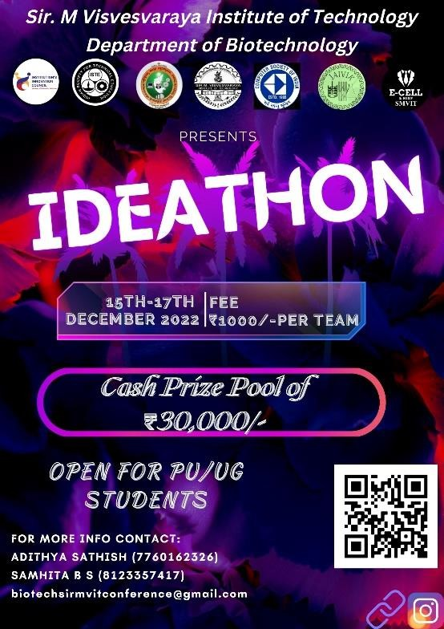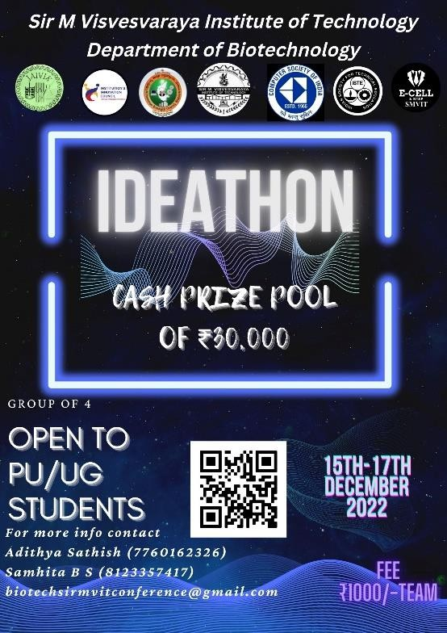

1. **Description (Total no of words:50)**

IDEATHON was conducted as a part of the 3-Day National Conference. A total of 20 groups registered for the event. On the 15th of December, the event was initiated, On the 17th of December, the final round of the event was conducted where each group presented their idea to the jury. Number of teams:20

Participants: 4/team- total of 80 Participants Prizes: total cash pool-30,000

Sponsored by: Computer society of India

1st place-15,000 won by student’s department of biotechnology, Sir MVIT 2nd place-10,000 won by students of Saptagiri college students

3rd prize-5,000 won by student of Sir MVIT

**Note: One needs to map your event title to any one of these:**

* 1. Design Thinking & Critical Thinking

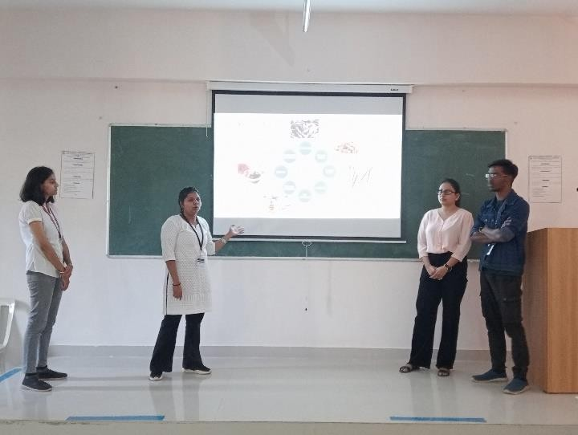 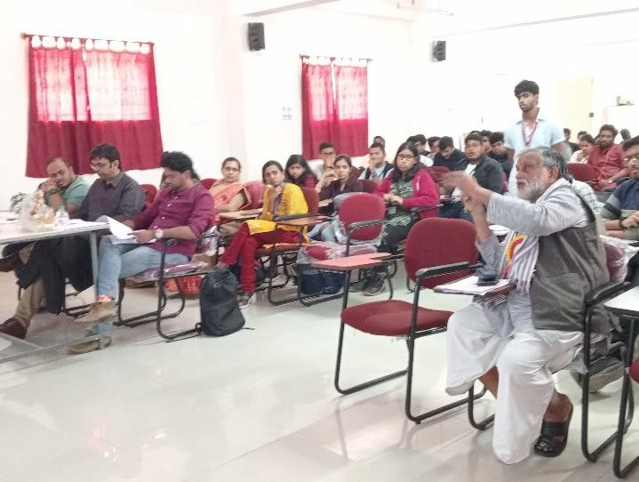

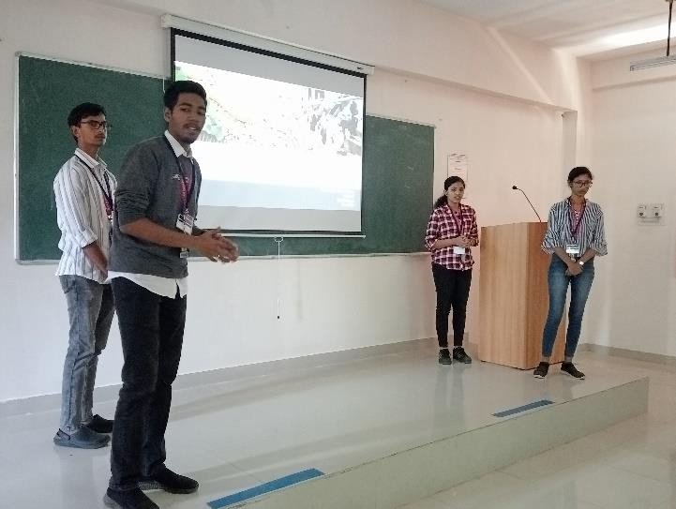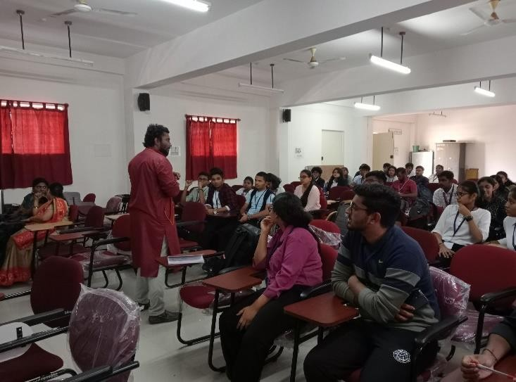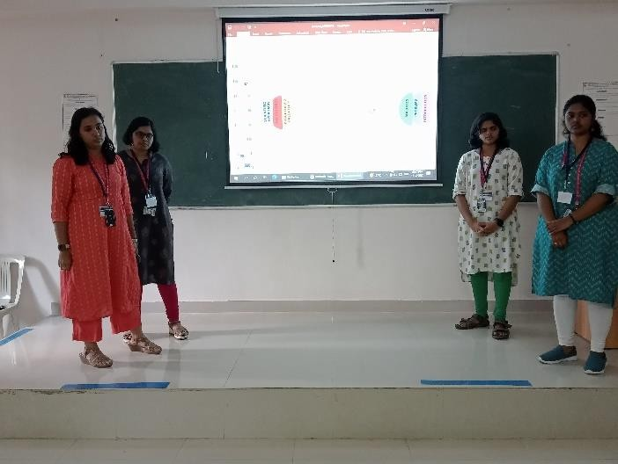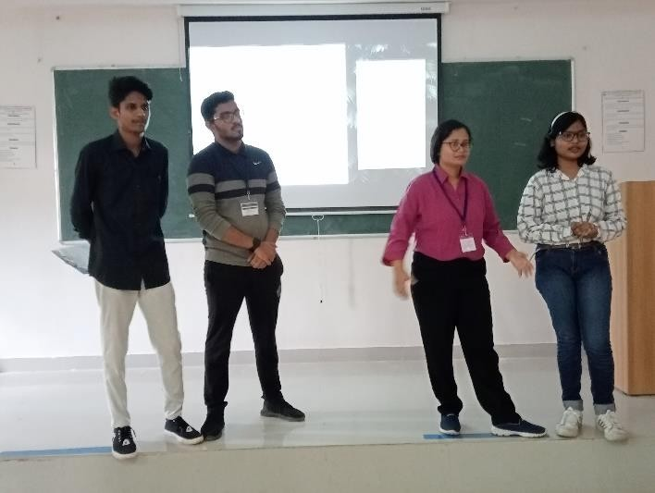

**SIR M VISVESVARAYA INSTITUTE OF TECHNOLOGY**

**E cell, NISP and Innovation Club**

1. **EVENT TITLE: “Emerging Technologies and Innovations for shaping the future of health care”(in Commemoration**

**of World Health Day)**

1. **START DATE: 6TH April 2023**
2. **END DATE: 6TH April 2023**
3. **URL of the Event: https://www.linkedin.com/feed/update/urn:li:activity:7049045478369349632**
4. **Brochure:**

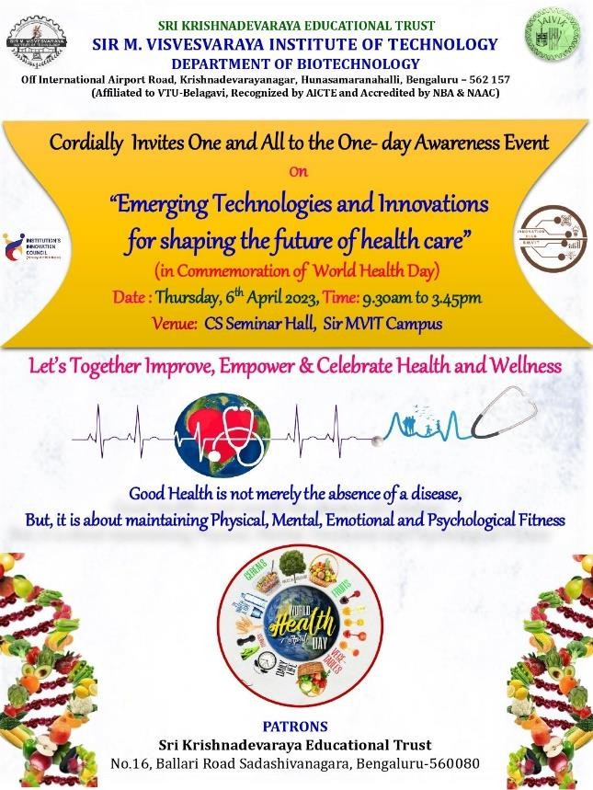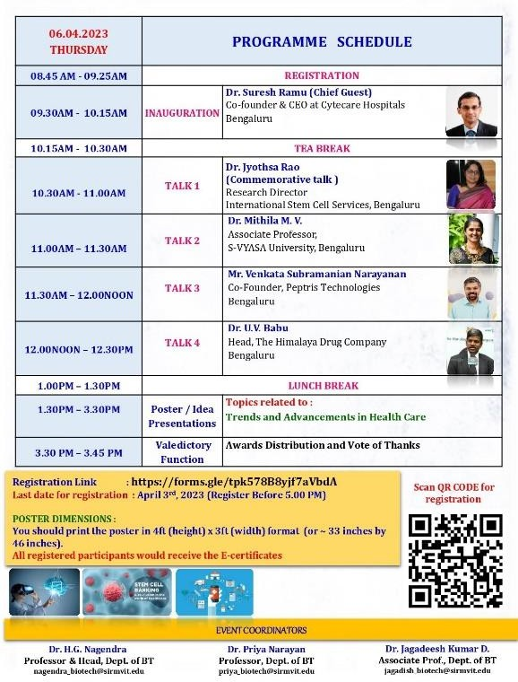

1. **Description (Total no of words:50)**

World Health Day was commemorated on 6th April 2023. The event started with a talk from Sri Suresh Ramu fom Cytecare Hospitals, Bangalore. The event also had expert lectures pertaining to Health care, oncology and Ayurveda. The Afternoon session had Poster sessions on innovative projects in Health Care.

Participants: 100

Prizes: total cash pool-5,000/-

Sponsored by: Aspartica Biotech Pvt. Ltd (Lunch sponsorship)

1st Place: Vandana and Team 2nd Place: Gururaj and Team 3rd Place: Pranesh and Team

**Note: One needs to map your event title to any one of these:**

* 1. Design Thinking & Critical Thinking

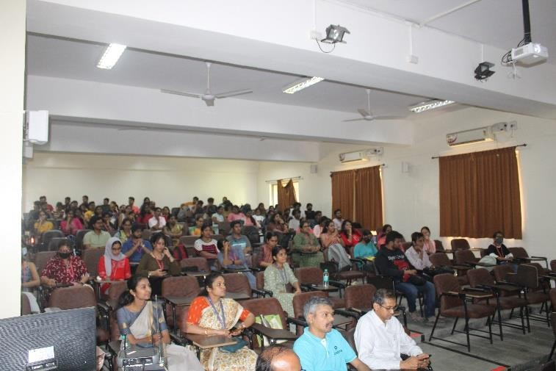 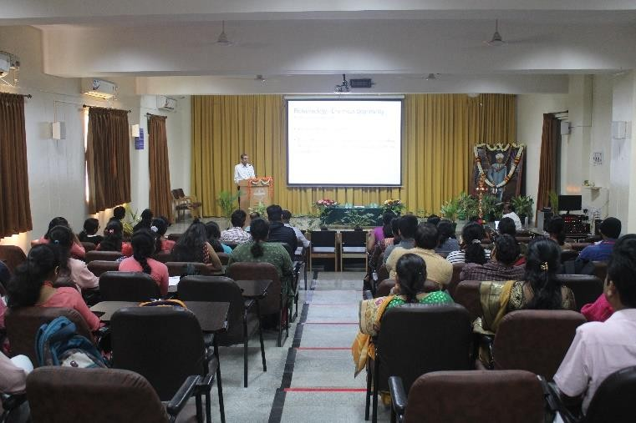

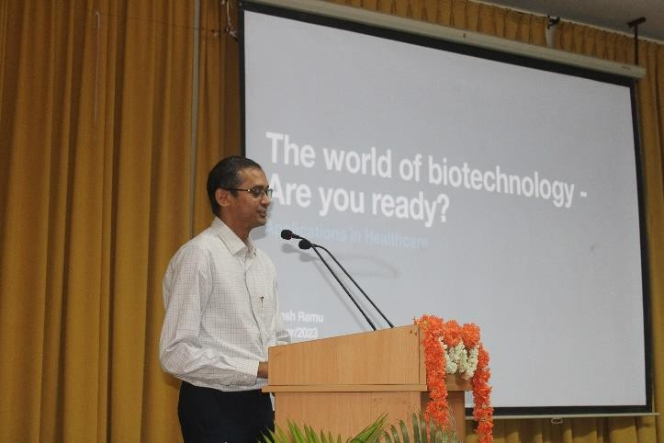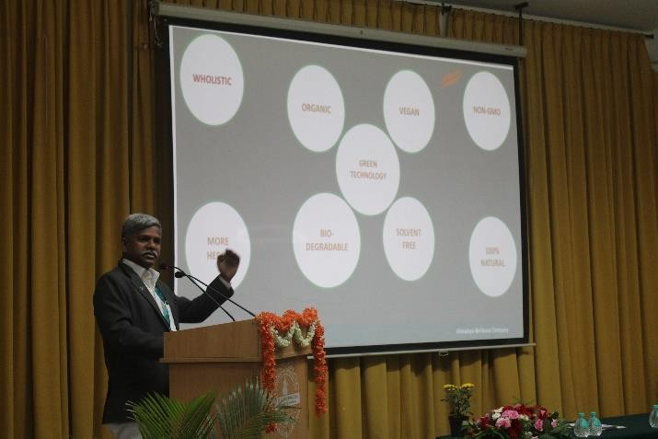

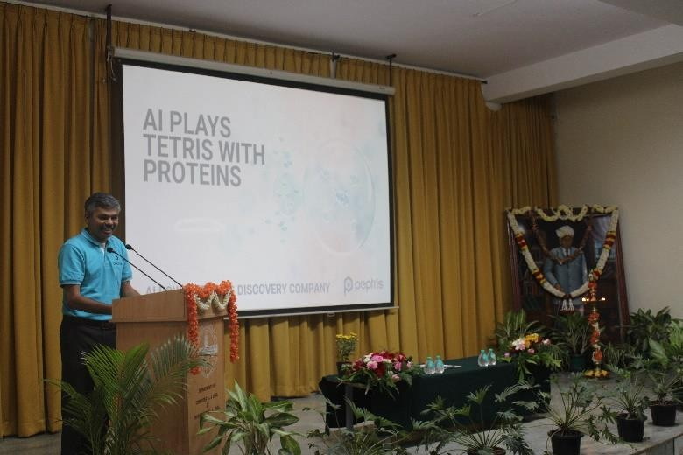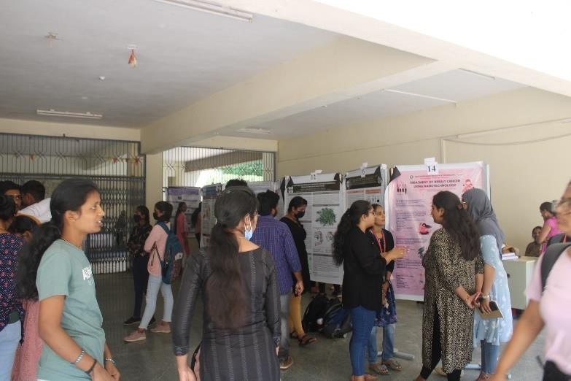

**SIR M VISVESVARAYA INSTITUTE OF TECHNOLOGY INSTITUTE INNOVATION COUNCIL**

**Celebration Activity**

* + 1. **EVENT TITLE: A Seminar on “Importance of Innovation and Creativity in HEIs”(In Commemoration of World Creativity and Innovation Day)**
    2. **START DATE: 21st April 2023**
    3. **END DATE: 21st April 2023**
    4. **SELECT EVENT THEME:**
       1. Design Thinking & Critical Thinking
    5. **URL of the Event:**
    6. **SELECT QUARTER:**
       1. Quarter III
    7. 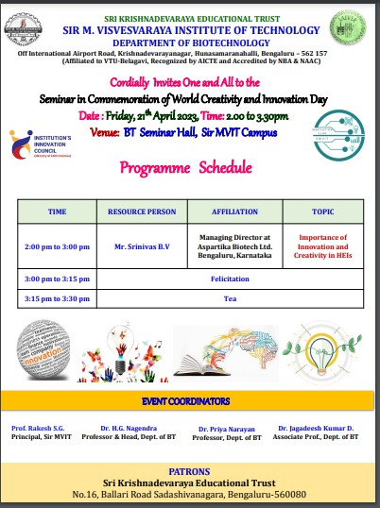**Brochure:**
    8. **Description (Total no of words:50)**

The World Creativity and Innovation Day was commemorated on 21st April 2023. The Resource person was Mr Shrinivas BV from Aspartika Biotech Pvt Ltd. Mr Shrinivas is also an elite alumnus of Sir MVIT. A talk on importance of innovations and creativity was highlighted during the talk. Interactions with students was very fruitful.

Mr Shrinivas was then felicitated and honored as distinguished alumnus who has contributed immensely towards Entrepreneurship and Innovation.

Participants: 100

Prizes: total cash pool-5,000/- Sponsored by: Sri KET

**Note: One needs to map your event title to any one of these:**

* + - 1. Design Thinking & Critical Thinking

